**Conductance of 4,4′-Bipyridine Single-Molecule Junctions with Silver Electrodes**

Zahidul Zahin1, Wanzhuo Shi2, and Latha Venkataraman2,3

1Lehman College – Department of Physics and Astronomy

2Columbia University -Department of Chemistry

3Columbia University -Department of Applied Physics and Mathematics

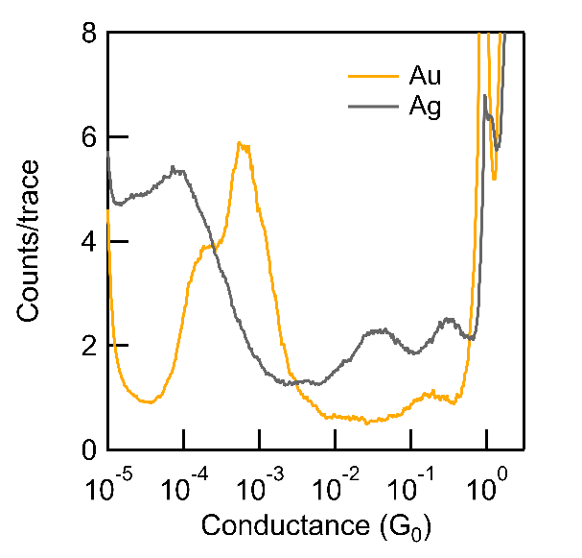

**Introduction**: Metal-molecule surfaces in single-molecule junctions effectively influence conductance, the most fundamental transport property. 1 Gold (Au) is the most commonly used electrode material due to its chemical inertness.2 However, other metals, like silver (Ag), are seldom used due to their instability and tendency to oxidize.4 In this study, we employ a modified Scanning Tunneling Microscope-based Break-Junction (STM-BJ) setup inside a glove box to measure the conductance of 4,4′-Bipyridine (BP) single-molecule junctions with silver and gold electrodes in an inert N2 atmosphere.

**Methods**: BP molecules are deposited on Au substrates via sublimation. Au/Ag tips are moved in and out to form metal-molecule-metal junctions repeatedly. Current (I) and bias (V) are continuously measured to calculate conductance G=I/V. After metal-metal contact initially forms, the tip retracts, thinning to single atomic contact, where the conductance is 1G0 (G0 = 2e2/h, quantum of conductance). Once ruptured, a molecule can bridge the nano-sized gap, resulting in a plateau indicating the molecular conductance level. Further withdrawal breaks the molecular junction, where conductance drops to electrical noise floor of the instrument. Process is repeated to collect thousands of conductance versus displacement traces for statistical analysis. All data was collected in nitrogen-purged glovebox setup.

**Results**: Ag-tip BP junctions exhibit lower conductance compared to Au-tip junctions. Additionally, Ag-tip junctions display a single conductance peak, while Au-tips have a double conductance feature in BP. We also find that there are features indicating the formation of Ag-O-Ag junctions at conductance’s higher than 10-2G0 indicating that our protocol for creating these junctions in a glove box is not yet optimized.

**Figure 1** – Logarithmically binned conductance histogram of BP junctions comparing Au & Ag electrodes. More than 4000 traces are compiled without data selection.

**Conclusions**: We measured the conductance of BP molecular junctions using STM-BJ technique with Au and Ag electrodes. Experimentally, we find lower conductance in Ag-tip junctions compared to Au, which could be attributed to the lower coupling strength at the Ag-molecule interface. Furthermore, Ag-tip junctions lack the characteristic double peak feature observed in Au due to reduced van der Waals interactions.3 In the future, theoretical studies should be conducted to further understand these results.

**Acknowledgements:**

This research was made possible through the generous support of the Columbia Amazon Summer Undergraduate Research Experience (SURE) Fellowship. Grateful acknowledgments are extended to Johnson Dalmieda2, Woojung Lee2, Liang Li2, Angela Paoletta2, Neil Chopra Bajaj2, and the Venkataraman Group for their invaluable contributions and unwavering support throughout this endeavor.

**References:**

(1) Su, T. A.; Neupane, M.; Steigerwald, M. L.; Venkataraman, L.; Nuckolls, C. Chemical principles of single-molecule electronics. *Nat Rev Mater* **2016**, *1* (3). DOI: ARTN 16002

10.1038/natrevmats.2016.2.

(2) Venkataraman, L.; Klare, J. E.; Nuckolls, C.; Hybertsen, M. S.; Steigerwald, M. L. Dependence of single-molecule junction conductance on molecular conformation. *Nature* **2006**, *442* (7105), 904-907. DOI: 10.1038/nature05037. Xu, B. Q.; Tao, N. J. J. Measurement of single-molecule resistance by repeated formation of molecular junctions. *Science* **2003**, *301* (5637), 1221-1223. DOI: DOI 10.1126/science.1087481.

(3) Adak, O.; Korytar, R.; Joe, A. Y.; Evers, F.; Venkataraman, L. Impact of Electrode Density of States on Transport through Pyridine-Linked Single Molecule Junctions. *Nano Lett* **2015**, *15* (6), 3716-3722. DOI: 10.1021/acs.nanolett.5b01195.

(4) Kaneko, S.; Nakazumi, T.; Kiguchi, M. Fabrication of a Well-Defined Single Benzene Molecule Junction Using Ag Electrodes. *J Phys Chem Lett* **2010**, *1* (24), 3520-3523. DOI: 10.1021/jz101506u. Kim, T.; Vazquez, H.; Hybertsen, M. S.; Venkataraman, L. Conductance of Molecular Junctions Formed with Silver Electrodes. *Nano Lett* **2013**, *13* (7), 3358-3364. DOI: 10.1021/nl401654s.