**Silver nanowire thin-film heaters in bioplastic microfluidic devices for molecular diagnostics**

Weiyi Zhang1, Abigail G. Ayers2, Samuel K. Sia2

1University of Connecticut, Department of Biomedical Engineering 2Columbia University in the City of New York, Department of Biomedical Engineering

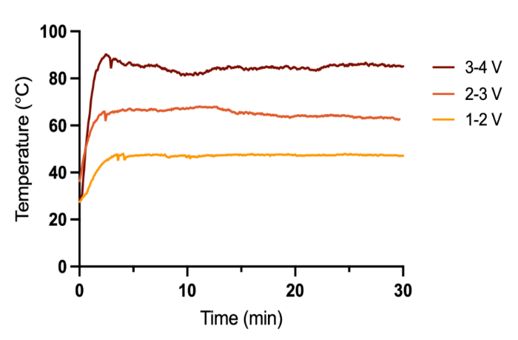**Introduction:** Microfluidics is an emerging technology for expanding access to molecular diagnostics, such as polymerase chain reaction (PCR) and loop-mediated isothermal amplification (LAMP), in point-of-care and low-resource settings. However, these microfluidic nucleic acid detection assays still rely on heating and extensive amplification steps predominantly requiring bulky, expensive laboratory equipment, thus limiting their application. This work seeks to develop a low-cost, minimal-equipment heating method by utilizing silver nanowires (AgNWs) as integrated heaters on microfluidic devices for nucleic acid amplification diagnostic assays.

**Methods:** We developed a custom fabrication technique to integrate AgNW and polylactic acid (PLA) into thin-film, transparent heater. Heating ability characterization was conducted using Arduino-powered thermocouples & Seek infrared thermal camera. We further demonstrated the utility of AgNW-PLA heater in a molecular diagnostic assay setting on a microfluidic chip by conducting isothermal amplification with the AgNW-PLA heater via RT-LAMP for detection of SARS-CoV-2 in saliva.

**Results:** We fabricated four AgNW-PLA heaters with resistance 10.5Ω ± 4.5643546 and heating efficiency of 40.12 kJ/min ± 25.6. We then examined the heating stability by applying various voltages to achieve targeted temperatures (45ºC, 65ºC, 85ºC) across all replicates. The heaters maintained consistent temperatures over a 30-minute time period, meeting the expectations of flexibility and reliability for heaters used in molecular diagnostics (Figure 1). Further, we demonstrated that the AgNW-PLA heater could be successfully integrated into a microfluidic platform for diagnostic detection of SARS-CoV-2 in saliva with an RT-LAMP assay, illustrated by amplification of 2 COVID targets and one positive control, and no negative control amplification.*Figure 1. Heating stability of AgNW-PLA heater (average temperature of replicates). Each replicate (n=2) required slightly different voltage to reach target temperatures (45ºC, 65ºC, 85ºC); voltage range shown in legend.*

**Conclusions:** The AgNW-PLA heater offers consistent, uniform heating at a small volume while utilizing minimal energy. The biodegradability of PLA simplifies disposal processes and promotes sustainability. We demonstrated the use of the AgNW heater in a microfluidic Reverse Transcription Loop-mediated Isothermal Amplification (RT-LAMP assay) based microfluidic for detection of for SARS-CoV-2, verifying the amplification of targeted genetic strands. Combining the compact design and the high sensitivity and accuracy molecular diagnostics can offer, these diagnostic tools signify great potential for application in point-of-care and resource-constrained environments.

**Acknowledgements:** Thanks to SURE program and Dr. Sia for this amazing opportunity. Special thanks to Abby for her tremendous support and reliable mentorship