MODULAR DRONE PLATFORM
Julian Kim^{1,2}, Junxi Xia¹, Liwen Tang¹, Yanchen Liu¹, Scott Zhao¹, Stephen Xia¹, Fred Jiang¹
¹Columbia University, ²Penn State University

Introduction: Indoor drones provide unparalleled monitoring of buildings and other tight spaces. However, their small size creates a challenge in meeting the wide range of applications due to the limited number of sensors they can carry. Our objective is to create a modular drone platform that facilitates autonomous sensor switching that would allow small indoor drones to execute a variety of tasks.
Methods: The skeleton of the Creality Ender 3 printer was used as a base for the drone platform due to its existing capabilities of moving in 3 dimensions. The X and Z axis motors were reutilized to control arms that grabbed the sensor module and lifted it to the drone landing platform above. The Y axis motor was replaced by a more powerful stepper motor in the same family (Nema 17) to drive the conveyor belt system.
Three methods were proposed to attach the sensor to the drone: electromagnets, magnets, and mechanical latching. Magnets were ultimately selected as the best candidate due to their simplicity and consistency (electromagnets required the use of high currents and mechanical options weren’t rated for consistent use).
Several prototypes of the sensor module were 3D printed to protect the sensors. The first one provided the appropriate structure to allow the arms to pick up the sensor, while future iterations improved features such as being light and increased stability using support beams and embedded magnets.
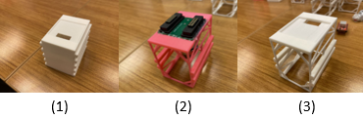
Figure 1. Sensor module prototypes
The conveyor belt system was adapted from the Ender Loop open-source project (Sgroi). The structural components were 3D printed with PLA, and the belt itself was constructed from cardboard. Magnets were embedded to keep the sensor module still while in motion.
Laser sensors are located across the conveyor belt directly below the landing platform to confirm the location of the sensor module, triggering the arms to attach and detach it accordingly. A Raspberry Pi 4 was used to establish communication between the laser sensors and the motors.
Results: We were able to run successful trials resulting in the sensor module being shifted into the right position by the conveyor belt, detected by the laser sensors, and attached to and detached from the drone on the landing platform.
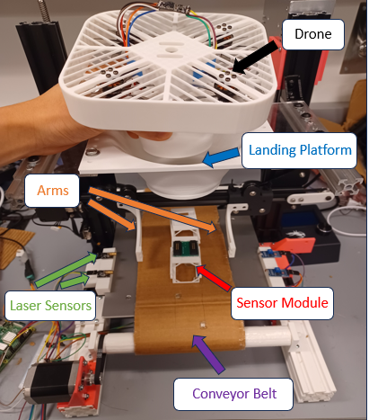
Figure 2. Constructed Drone Platform
Future Work: Further testing is necessary to ensure sensor and drone compatibility. The addition of a camera would allow for the identification and tracking of multiple sensor modules. Implementation of an auto-charging module for the drone.
Acknowledgements:
This research experience was sponsored by the Columbia-Amazon Summer Undergraduate Research Experience (SURE) Program.
This work was supported in part by COGNISENSE, one of seven centers in JUMP 2.0, a Semiconductor Research Corporation (SRC) program sponsored by DARPA. The views and conclusions contained here are those of the authors and should not be interpreted as necessarily representing the official policies or endorsements, either expressed or implied, of Columbia University, SRC, DARPA, or the U.S. Government or any of its agencies.
The conveyor belt design was adapted from the Ender Loop project developed by Michael Sgroi, as per https://creativecommons.org/licenses/by-nc/4.0/

