Processing MRI Images of Bubbles Injected into Liquid Suspensions

***Daniela Ayala****\*, Alireza Bordbar**, Christopher M. Boyce*.*

**Introduction**: Understanding the dynamics of bubble formation and movement is crucial in both industrial and natural settings. In natural processes, such as volcanoes, bubbles rise, split, and coalesce in magma. These bubble dynamics also have significant effects on interphase heat and mass transport, as well as the mixing of liquid and suspended particles. Jets of bubbles injected through a single nozzle into a liquid are common in various industrial processes. The research focuses on MRI imaging of bubbles in high-viscosity silicone oil with varying sesame seed percentages (0%, 10%, and 20%) to detect "regular coalescence." However, to detect the bubble patterns, the displayed images require processing and enhancement for better clarity.

**Method**: The experimental setup used involves a 3D cylindrical system. The system has a diameter of 18 cm and a height of 38 cm, with the mixture filled up to a height of 35 cm. To generate a stream of bubbles, air is vertically injected through a one-way valve positioned at the center of the system's base. The air injection has a wait time of 700ms, followed by an injection time of 160ms.

To process the MRI images, MATLAB was used, and various functions were implemented for rotating, brightening, normalizing, and binarizing the MRI images (Fig. 1).

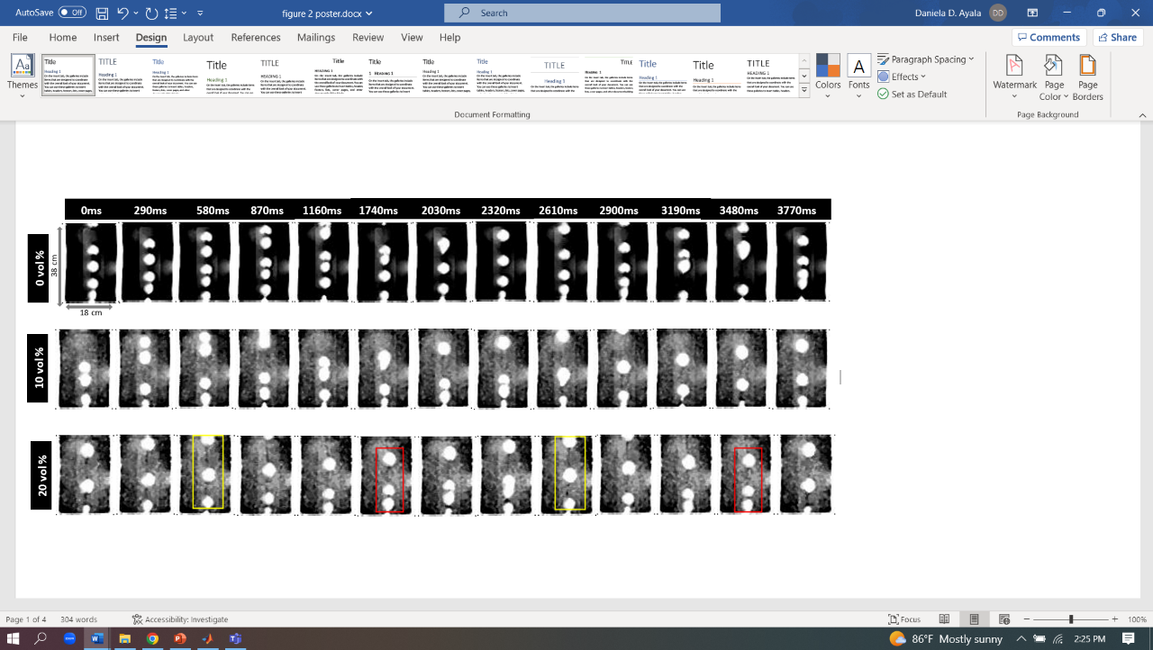**Results**: In the zero and ten percent sesame seed mixture, no visible pattern of bubble formation was observed. However, in the twenty percent sesame seed mixture, a distinct and captivating pattern of bubble coalescence and formation emerged. This phenomenon was consistently evident every 5th frame, manifesting in the exact locations as seen in Figure 2.

**Conclusion**: The study focused on understanding the dynamics of bubble formation and movement in a 3D cylindrical system filled

with high-viscosity silicone oil and varying percentages of sesame seeds (0%, 10%, and 20%). Through MRI imaging and image processing techniques, it was observed that the 20% sesame seed mixture displayed a clear pattern of bubble coalescence in the same locations every 5th frame.

To further investigate bubble dynamics and coalescence, future studies should consider exploring additional sesame seed percentages and their effects on the formation patterns. Additionally, studying the impact of external factors, such as temperature and pressure variations, could enhance the understanding of bubble dynamics in different environments.

**Figure. 1**

**Figure. 2**

**References**:

A. W. Woods, Turbulent Plumes in Nature, Annu. Rev. Fluid Mech. 42, 391 (2010).

M. C. Boufadel, S. Socolofsky, J. Katz, D. Yang, C. Daskiran, and W. Dewar, A Review on Multiphase Underwater Jets and Plumes: Droplets, Hydrodynamics, and Chemistry, Rev. Geophys. 58, e2020RG000703 (2020).

S. R. Syeda and A. M. Ansery, Formation and Development of Submerged Air Jets, J. Mech. Eng. 44, 137 (2015).