The regulatory effect of GAG-mimetics on activated human osteoarthritic chondrocytes
Nigel Cole¹, Omar Alheib² , Treena Livingston Arinzeh².
Southern University A&M¹, Department of Biomedical Engineering, Columbia University²

Introduction: Osteoarthritis (OA) is a degenerative joint disease characterized by the progressive breakdown of articular cartilage. As OA progresses, it causes pain, stiffness, and loss of joint function, affecting 528 million people, or approximately 7% of the global population [1]. Due to the limited regenerative ability of articular cartilage, damage to this tissue can result in long-term functional impairment and pain. Current treatments for OA primarily focus on mitigating pain symptoms, and there is no drug capable of effectively halting the progression of the disease [2]. Tissue engineering is a biomedical engineering discipline that creates biological substitutes to replace diseased or damaged human tissue e.g. cartilage tissue. Glycosaminoglycans (GAGs) are the main component in the cartilage tissue, essential for providing homeostasis in cartilage tissue [3]. Herein, we used a mimetic of sulfated GAGs derived from cellulose to examine its effect on OA chondrocytes. Electrospinning technique was used to produce fibrous scaffolds containing the GAG mimetic. The scaffolds were seeded with OA chondrocytes and cultured in the presence of pro-inflammatory molecules.
Methods: Scaffolds were prepared using previously described methods [4]. Briefly, scaffolds were fabricated using 24% (w/w) bovine gelatin (Sigma) in 63/37 acetic acid/water solutions and 5% (w/w) partially sulfated cellulose (pSC, prepared as published), which is a glycosaminoglycan (GAG)-mimetic. The scaffolds were crosslinked using 200 mM 1-3 ethylcarbodiimide hydrochloride (EDC, Sigma) and 40 mM N-hydroxysuccinimide (NHS, Sigma) to enhance hydrolytic stability and retain fibrous structures in aqueous environments as previously established. Additional materials included ethanol (200 proof, Sigma), phosphate-buffered saline (PBS, Fisher Scientific), Dulbecco's Modified Eagle's Medium (DMEM, Fisher Scientific), fetal bovine serum (FBS, Hyclone), antibiotic-antimycotic (Fisher Scientific), trypsin (Fisher Scientific), poly-L-lysine (Sigma), paraformaldehyde (Sigma), Triton X-100 (Sigma), bovine serum albumin (BSA, Fisher Scientific), DAPI (Fisher Scientific), Quant-iT PicoGreen dsDNA Assay Kit (Fisher Scientific), and papain (Sigma).. TGF-β3 & IL-1β were added to chondroinductive media (CCM+) media. The live/dead cytotoxicity staining, immunostaining for cartilage matrix molecules, dsDNA assay for cell growth (PicoGreen), and MMP-13 ELISA assay were performed. Statistical significance was determined using two-way ANOVA and Tukey’s post-hoc tests.
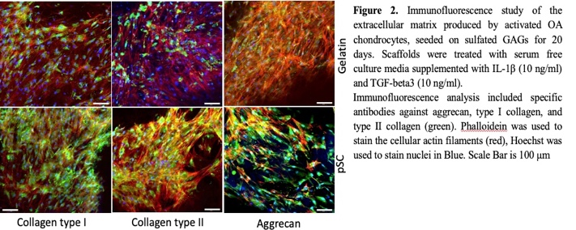
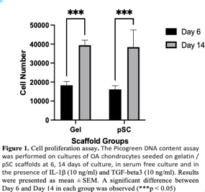
Results: Cells produced MMP-13, an enzyme typically associated with OA chondrocytes, was produced on both scaffolds. Statistical differences were not detected between groups (Figure 1). Cell growth was determined over time for both scaffolds and cell viability was maintained over time. Cartilage matrix was produced that included both collagen types I and II and aggrecan where it appeared more intense staining was present for scaffolds containing pSC, the GAG-imetic.

Conclusion: GAG-mimetic containing scaffolds demonstrated OA chondrocyte growth and viability even in the presence of the proinflammatory cytokine IL-1β. OA chondrocytes were able to deposit major cartilage matrix components, collagen types I and II and aggrecan with the appearance of greater matrix deposition on the GAG-mimetic containing scaffold. Cell produced MMP-13, an enzyme typically associated with matrix degradation by OA chondrocytes. Future studies are needed to further understand the influence of GAG-mimetics on cartilage formation by OA chondrocytes.
References:
- Leifer VP, Katz JN, Losina E. The burden of OA-health services and economics. Osteoarthritis Cartilage. 2022 Jan;30(1):10-16. doi: 10.1016/j.joca.2021.05.007. Epub 2021 May 20. PMID: 34023527; PMCID: PMC8605034.
- Menezes R, Sherman L, Rameshwar P, Arinzeh TL. J Biomed Mater Res A. 2023;111(2):37496.
- Grässel S, Muschter D. Recent advances in the treatment of osteoarthritis. F1000Res. 2020 May 4;9:F1000 Faculty Rev-325. doi: 10.12688/f1000research.22115.1. PMID: 32419923; PMCID: PMC7199286.
Acknowledgements
The author acknowledges the fellowship opportunity sponsored by the Columbia-Amazon Summer Undergraduate Research Program (SURE), and the additional support from Thornton Tomasetti.

